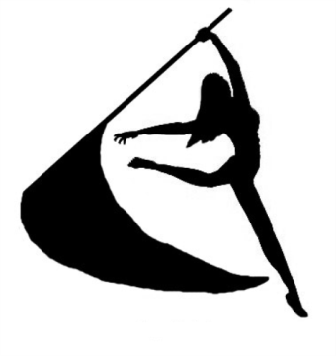 Keller Indian Color Guard
2017-2018 Sponsorship Form
Sponsorships are an essential part of a successful band season! Please consider supporting the Keller Indian Color Guard at this level and help the Guard perform to their full potential!
Company Sponsorship:
Business Name____________________________________________________ Cell _________________________________
Contact Name_____________________________________________________ Cell _________________________________
Address__________________________________________________________ Phone_______________________________
Main E-mail_____________________________________________________________________________________________

Family Sponsorship:
Parent Name______________________________________________________ Cell _________________________________
Parent Name______________________________________________________ Cell _________________________________
Student Name______________________________________________________Grade________________________________
2nd Student Name___________________________________________________ Grade_______________________________
Address__________________________________________________________ Phone_______________________________
Main E-mail____________________________________________________________________________________________
Sponsorship incentives are listed on the back of this page. Sponsorships are good for one full year.

Please choose one of the sponsorship levels below for either Family or Company:
- Blue - $1,000
- Gold - $500
- White - $250

Total Amount Due $________ Check #_______ Cash ______

Date: __________________________

Checks payable to: KHS Band Boosters - Color Guard
Mail to: KHS Band Boosters Association, P.O. Box 1573, Keller TX 76244

$1,000 Blue Level provides the following:
- Company logo on banner displayed at band events and football games
- Public address announcement recognition at football game halftime shows
- Recognition in electronic newsletters sent by Band Boosters including name, phone and link to website
- Company logo on Indian Band web site Home Page with link to company web site
- $25 Spirit Sales Voucher
- Sponsor Certificate for office or home
- Color Guard Photo for office or home
- 1/2 page advertising space in band banquet program booklets
- Name listed in concert programs
- 2 Color Guard Decals
- 2 Photo Buttons (Family Membership Only, unless sponsor has a student in the band)

$500 Gold Level provides the following:
- Recognition in electronic newsletters sent by Band Boosters including name and phone
- Company name on Sponsor page of Indian Band web site with link to company web site
- $20 Spirit Sales Voucher
- Sponsor Certificate for office or home
- Color Guard Photo for office or home
- 1/4 page advertising space in band banquet program booklets
- Name listed in concert programs
- 2 Color Guard Decals
- 2 Photo Buttons (Family Membership Only, unless sponsor has a student in the band)

$250 White Level provides the following:
- Company name on Sponsor page of Indian Band web site
- $15 Spirit Sales Voucher
- Sponsor Certificate for office or home
- Indian Band Photo for office or home
- Company name listed in band banquet program booklets
- Name listed in concert programs
- 2 Color Guard Decals
- 2 Photo Buttons (Family Membership Only, unless sponsor has a student in the band)

Sept 2017

